THIS ENDORSEMENT CHANGES THE POLICY. PLEASE READ IT CAREFULLY.

LEASED, RENTED OR LOANED AUTO EXCLUSION

This endorsement modifies coverage provided under the following:

AUTO DEALERS COVERAGE FORM

With respect to coverage provided by this endorsement, the provisions of the Coverage Form apply unless modified by this endorsement.

This endorsement changes the policy on the inception date of the policy unless another date is indicated below.

Named Insured:  Morris Avenue Auto Sales | Policy Number:
Endorsement Effective:  11/4/2025 | Countersigned By:  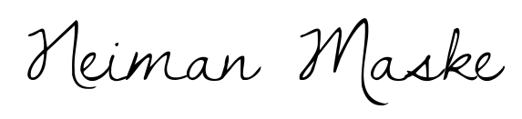
(Authorized Representative)

If no entry appears above, information required to complete this endorsement will be shown in the Declarations.

SECTION I – COVERED AUTOS COVERAGES, D. Covered Autos Liability Coverage, 4. Exclusions, G. Leased Autos is replaced by:

G. Leased, Rented or loaned Autos

Any covered “auto” while leased, rented, or loaned to others.

SECTION I – COVERED AUTOS COVERAGES, F. Physical Damage Coverage, 3. Exclusions, b (1) is replaced by:

Any covered “auto” while leased, rented, or loaned to others.

This endorsement shall apply to any continuation, reinstatement, or renewal of the captioned policy by the Named Insured.

I have read, understand and agree to the above statement and my signature and date are shown below.

________________________________________________ ______________________
Signature of Insured Date

